**A PROJECT REPORT ON**

**Connect4 Game in Prolog**

**Artificial Intelligence and Robotics**

**SUBMITTED BY**

Yoganand Kanhed ( 402077)

Vaibhav Gole (402062)

Rishikesh Kakad (402075)



**Department of Computer Engineering**

**MAEERs MAHARASHTRA INSTITUTE OF TECHNOLOGY**

**Kothrud, Pune 411 038**

**2018-2019**

**TITLE:**

Connect4 Game Using PROLOG

**DOMAIN:**

Artificial Intelligence, Machine Learning

**PROBLEM STATEMENT:**

Implement A-star algorithm for four connect game.

**FLOWCHART:**

Game Grid(6X7)

Moves by User and Machine respectively

Winner i.e User or Machine

**ALGORITHM STEPS:**

1. Initialize the open list
2. Initialize the closed list put the starting node on the open list (you can leave its f at zero)
3. While the open list is not empty
   1. find the node with the least f on the open list, call it "q“
   2. pop q off the open list
   3. generate q's 8 successors and set their parents to q
   4. if successor is the goal, stop search successor
   5. push q on the closed list end (while loop)

**OUTPUT:**

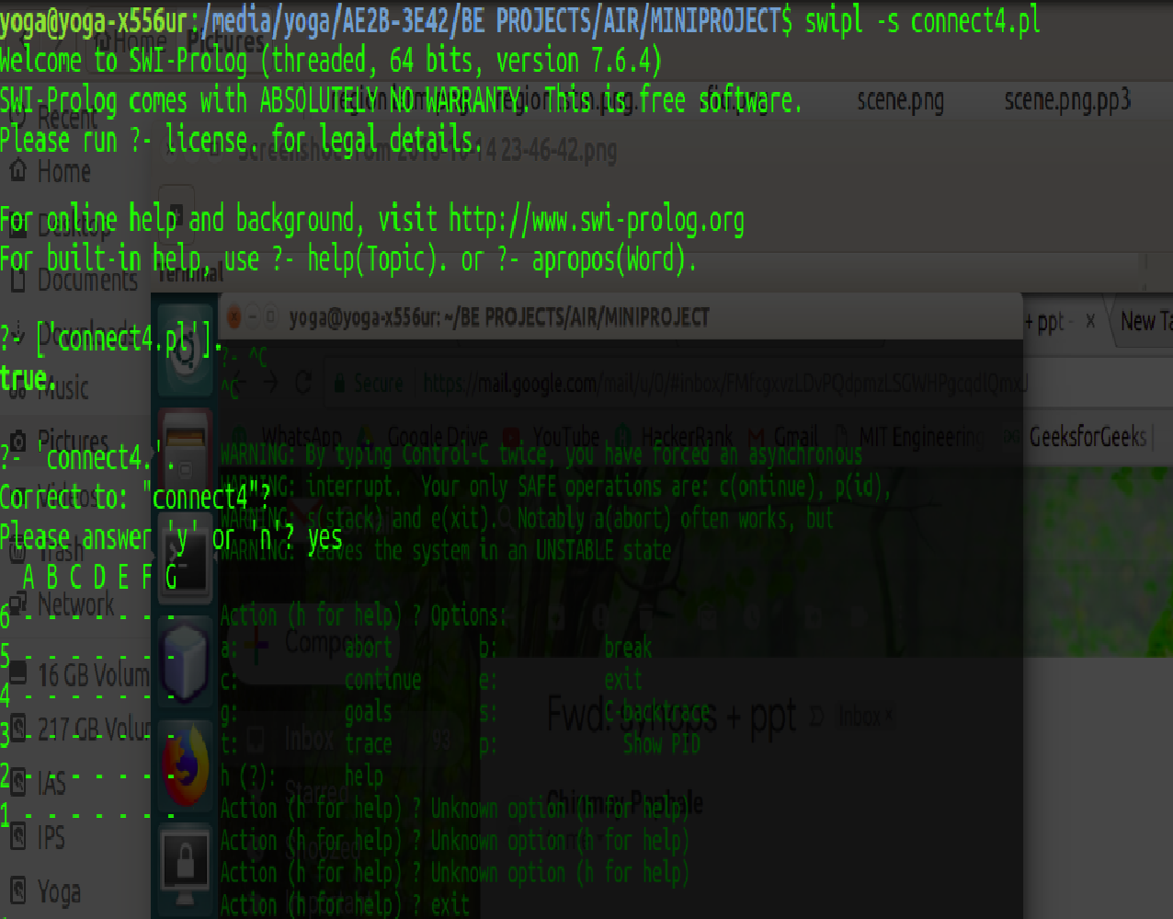

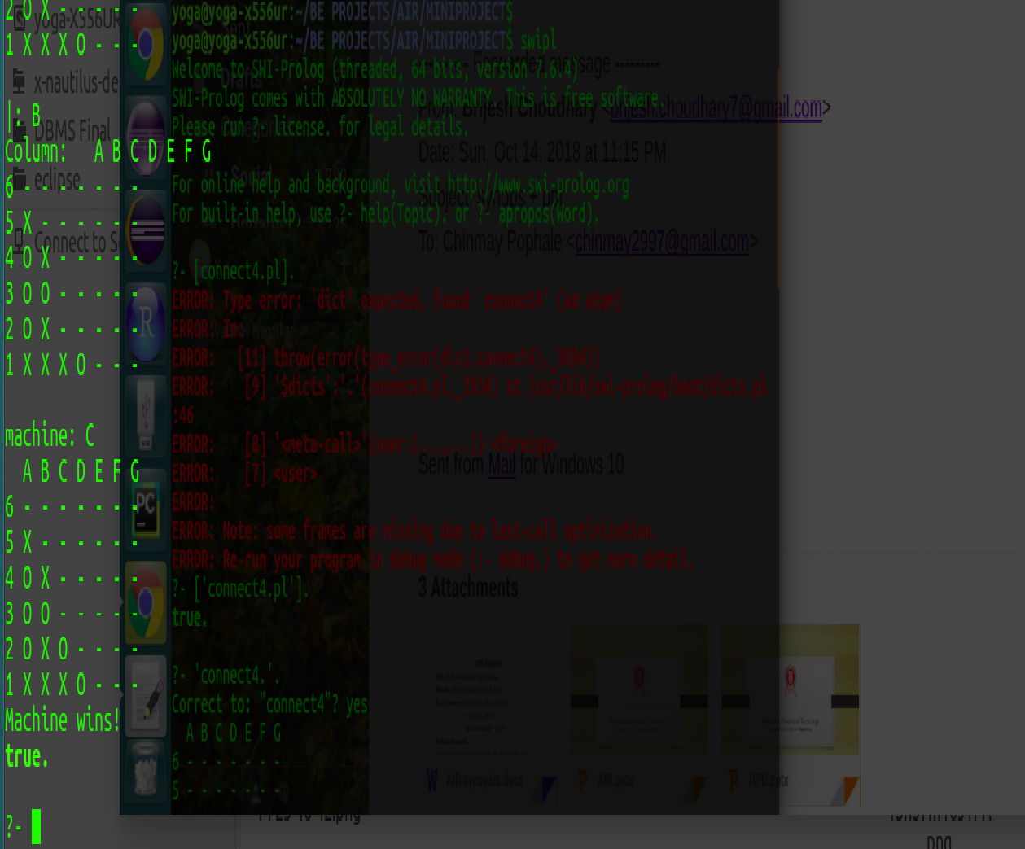

**SOFTWARE/HARDWARE REQUIREMENTS :**

1. Linux ubuntu
2. 64-bit Operating System
3. SWI-Prolog 7.6.4

**APPLICATIONS -**

* In pathfinding operation
* In graph traversal
* Parsing using stochastic grammers in NLP
* Information search with online learning.

**CONCLUSION:**

The Astar algorithm is implemented for the four connect game.

**FUTURE SCOPE -**

1. More study can be conducted in integration of rule and case based systems.
2. It can be extended to more user friendly user interface.
3. It can be used to develop career based on different programming languages.

**REFERENCES**

* Dahl, V., “Logic Programming as a Representation of Knowledge,”​*IEEE Computer, Vol. 16*, October, 1983.
* The sites referred are:
* en.wikipedia.org http://www.swi-prolog.org/ http://www.learnprolognow.org/
* http://kti.mff.cuni.cz/~bartak/prolog/
* https://en.wikipedia.org/wiki/Backward_chaining